Motion and Forces

Name: _____________________

1 A car travelling at 16 m s–1 accelerates uniformly at 3 m s–2 for 4 s. Find its final velocity.

(2 marks)

2 How far will the car in question 1 travel in this time?

(1 mark)

3 A car is travelling at 99 km h–1 when the driver notices a cow on the road. It takes him 1.4 s to put his foot on the brake, and a further 2.4 s to stop. How far does the car travel from when he first saw the cow until he stops (assuming he doesn’t hit the cow)?

(4 marks)

4 A ball is propelled vertically upwards from a 40 m high cliff at a speed of 8 m s–1. Ignore air resistance.

a Find the maximum height the ball will rise. (3 marks)

b At what speed will the ball hit the ground below the cliff? (2 marks)

c How long will it spend in the air? (1 mark)

5 The following velocity–time graph represents a cyclist’s journey.

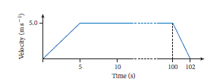

a What was his maximum speed? (1 mark)

b Did he brake more rapidly than his initial acceleration? How can you tell?

(2 marks)

c What was his final acceleration? (2 marks)

d How far did he ride? (2 marks)

6 A force F N moves a mass of m kg through a displacement of s m as shown below. How much work has been done?

(3 marks)

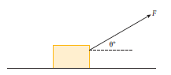

7 The following graph shows the work done by a 20 N force acting for 8 m in the direction of motion.

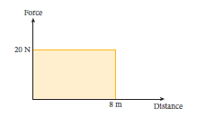

a How much work is done by the force? (2 marks)

b How much work would be done by the force if it was acting perpendicular to the motion? (1 mark)

8 A 10 kg rocket takes 4 s to ascend vertically from rest to a height of 20 m, at which time it is travelling at 12 m s–1. What is the average power in the rocket motor? (3 marks)

9 A 1500 kg SUV travelling at 90 km h–1 collides head-on with a 1 t car travelling at 60 km h–1. Immediately after the collision the two vehicles move together as one.

a At what speed will they move? (2 marks)

b Is this an elastic collision? Why, or why not? (2 marks)

10 A 5 kg mass slides down a frictionless plane inclined at 25° to the horizontal.

a Draw this on a diagram, showing all forces on the 5 kg mass. (2 marks)

b If the distance from the mass to the bottom of the plane is 1 m, what will the object’s speed be when it reaches the bottom of the plane?

(3 marks)